COMPUTER VISION
Project 2: People Counting with Color and Depth Data

Objective:
Develop a simple computer vision application that takes in input a color image together with the corresponding depth map and is able to count the number of people in the scene.

Class Layout
I am developed the class PeopleCounting in the utilities file, this class contains all the method for the people counting but only two are public. The first is the method that set the background of the room, that must be execute before the execution of the second method that really count the people. The folder contains also a main file that recall the methods present in the first file.

Img 1: Input depth image
Method:
My application use only the depth images to find the people and the color images are used to print the result to have a better visible feedback;
My application divides itself in four parts:
- Background Removal
- Clean Image
- Find people
- Draw

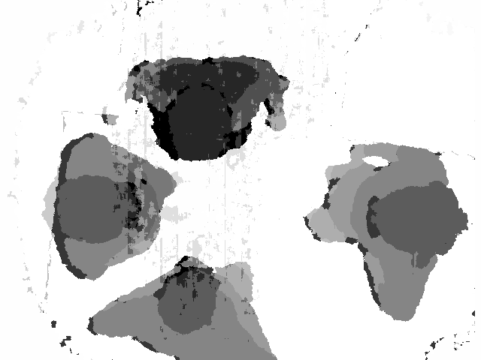Img 2: image obtained with the background removal

Background removal

The image without the background is obtained transform the image and the background in grayscale, then at both images the histogram equalization is computed.
So the result image ( Img 2. ) is calculated as negative of difference of negative between the image with people and the background image.

Clean Image
In this phase the noise is remove to the image.

First of all two thresholt were applied to the image to have a better contrast (Img 3.).

Second a gaussian blur of 9x9 was applied to remove a little noise (Img 4.).
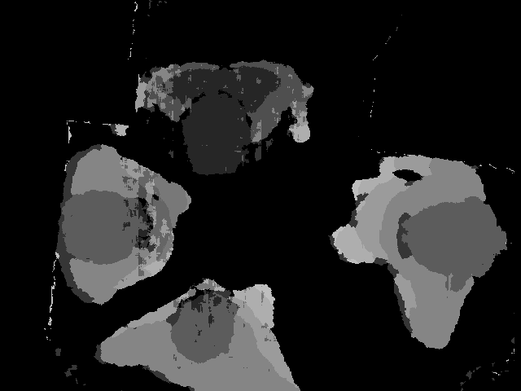Img 3: image after thresholding
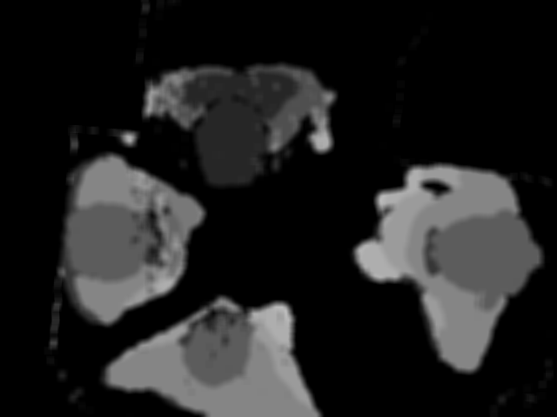Img 4: Image after blur

Then some operations of dilate and erose were applied to the image, this operations allow to see the people in the image as blob (Img 5-8.).

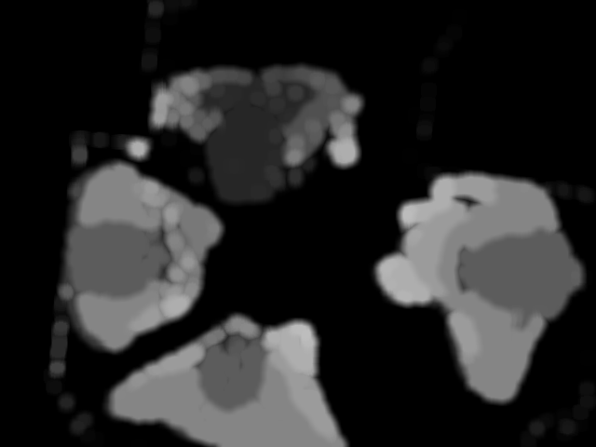Img 5: First Dilate
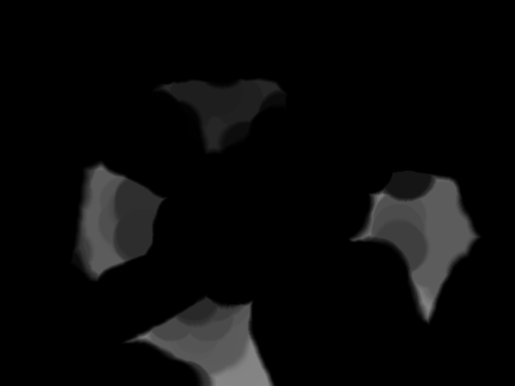Img 6: First Erosion

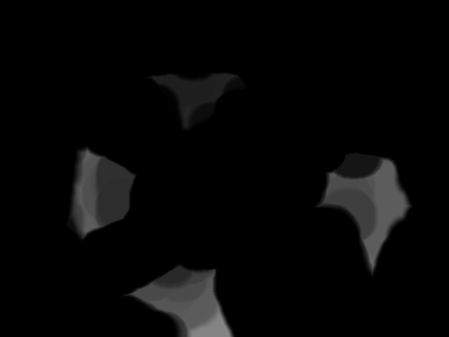Img 7: Second Erosion
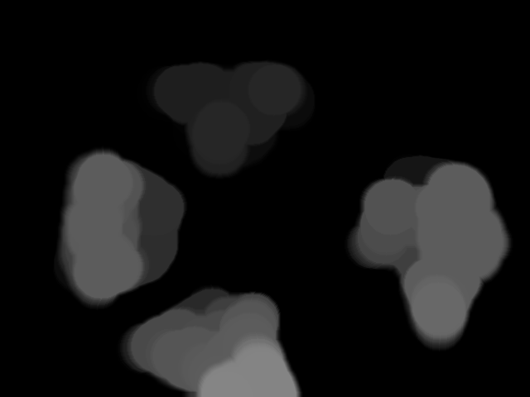Img 8: Second Dilate

Finally with the equalization of histogram the image is ready to the blob detection (Img 9.).
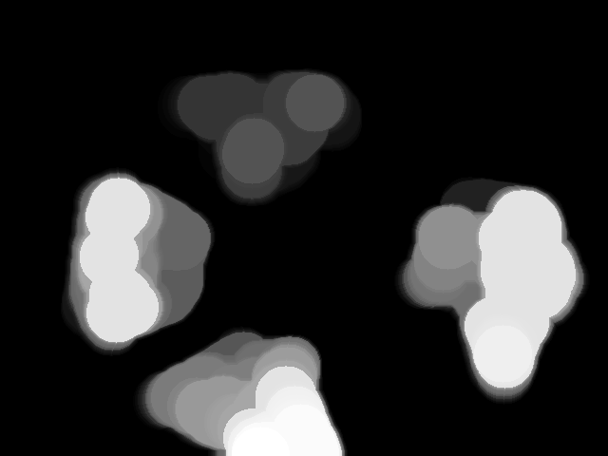Img 9: Image ready for blob detection

Find People
This method execute a Simple Blob detector provided by OpenCV that set a vector of keypoint that represent the centers of each blobs and their dimension.

Draw
The draw method draw some green circles centered in the keypoints setted in the past method with the values of radiuses equal to the dimension of blob (Img 11.).

Results
This method work for all tested images also if some images has the centers of blobs little moved from the center of the people, this can be caused by two people that are closer or by that the two representations (color and depth) have been acquired from slightly different viewpoints.

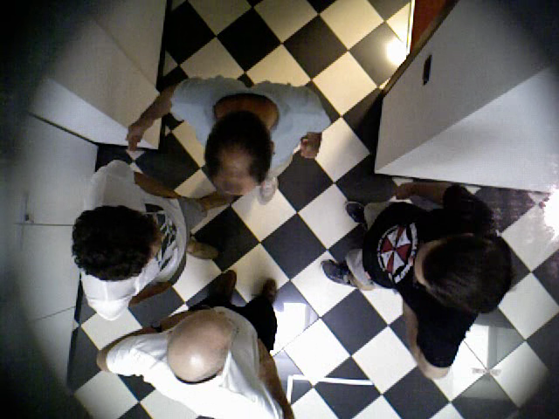Img 10: Input Color Image

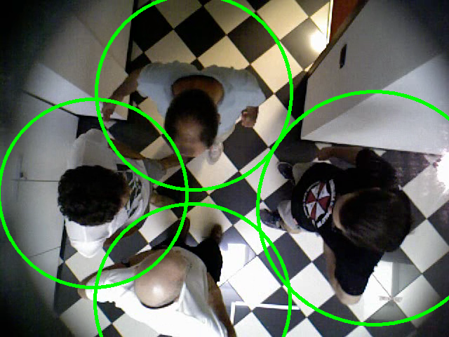Img 11: Result Image

